Chapter 10: Estimating With Confidence

Objectives: Students will:
Describe statistical inference.
Describe the basic form of all confidence intervals.
Construct and interpret a confidence interval for a population mean (including paired data) and for a population proportion.
Describe a margin of error, and explain ways in which you can control the size of the margin of error.
Determine the sample size necessary to construct a confidence interval for a fixed margin of error.
Compare and contrast the t distribution and the Normal distribution.
List the conditions that must be present to construct a confidence interval for a population mean or a population proportion.
Explain what is meant by the standard error, and determine the standard error of and the standard error of .

AP Outline Fit:
III. Anticipating Patterns: Exploring random phenomena using probability and simulation (20%–30%)
D. Sampling distributions
7. t-distribution
IV. Statistical Inference: Estimating population parameters and testing hypotheses (30%–40%)
A. Estimation (point estimators and confidence intervals)
1. Estimating population parameters and margins of error
2. Properties of point estimators, including unbiasedness and variability
3. Logic of confidence intervals, meaning of confidence level and confidence intervals, and properties of confidence intervals
4. Large sample confidence interval for a proportion
6. Confidence interval for a mean
7. Confidence interval for a difference between two means (unpaired and paired)

What you will learn:

- Confidence Intervals for µ (σ known)
  - State in nontechnical language what is meant by “95% confidence” or other statements of confidence in statistical reports.
  - Calculate a confidence interval for the mean µ of a Normal population with known standard deviation σ, using the recipe .
  - Recognize when you can safely use this confidence interval and when the data collection design or a small sample from a skewed population makes it inaccurate. Understand that the margin of error does not include the effects of undercoverage, nonresponse, or other practical difficulties.
  - Understand how the margin of error of a confidence interval changes with the sample size and the level of confidence C.
  - Find the sample size required to obtain a confidence interval of specified margin of error m when the confidence level and other information are given.
- Confidence Intervals for µ (σ unknown)
  - Use the t procedures to obtain a confidence interval at a stated level of confidence for the mean µ of a population.
  - Recognize when the t interval is appropriate in practice, in particular that it is quite robust against lack of Normality but is influenced by outliers.
  - Also recognize when the design of the study, outliers, or a small sample from a skewed distribution make the
t procedures risky.
  - Recognize paired-data designs and use the one-sample t procedures to obtain confidence intervals for such data.
- Confidence Intervals for p
  - Use the z procedure to give a confidence interval for a population proportion p.
  - Check that you can safely use the z procedures in a particular setting.
  - Determine the sample size required to obtain a level C confidence interval with a specified margin of error.
Section 10.I: Introduction to Estimating With Confidence

Knowledge Objectives: Students will:
Explain what is meant by statistical inference.
Explain how probability is used to make conclusions in statistical inference.

Construction Objectives: Students will be able to:

Vocabulary:
Statistical Inference – provides methods for drawing conclusions about unknown population parameters from sample data (statistics). Since different samples can yield different results, we express our findings in terms of probabilities to measure the strength of our conclusions.
Confidence Intervals – an interval around an estimate of a population parameter that we are C% confident that the true population parameter lies in it
Significance Tests – tests that assess a claim about a population parameter

Key Concepts:

Reasoning of Statistical Estimation:
- Use unbiased estimator of population parameter
- The unbiased estimator will always be “close” – so it will have some error in it
- Central Limit theorem says with repeated samples, the sampling distribution will be apx Normal
- Empirical Rule says that in 95% of all samples, the sample statistic will be within two standard deviations of the population parameter
- Twisting it: the unknown parameter will lie between plus or minus two standard deviations of the unbiased estimator 95% of the time

Homework: None
Section 10.1: Confidence Intervals: The Basics

Knowledge Objectives: Students will:
List the six basic steps in the reasoning of statistical estimation.
Distinguish between a point estimate and an interval estimate.
Identify the basic form of all confidence intervals.
Explain what is meant by margin of error.
State in nontechnical language what is meant by a “level C confidence interval.”
State the three conditions that need to be present in order to construct a valid confidence interval.
List the four necessary steps in the creation of a confidence interval (see Inference Toolbox).
Identify three ways to make the margin of error smaller when constructing a confidence interval.
Identify as many of the six “warnings” about constructing confidence intervals as you can. (For example, a nice formula cannot correct for bad data.)
Explain what it means by the “upper p critical value” of the standard Normal distribution.

Construction Objectives: Students will be able to:
For a known population standard deviation σ, construct a level C confidence interval for a population mean.
Interpret a confidence interval in the context of the problem.
Determine the sample size necessary to construct a level C confidence interval for a population mean with a specified margin of error.

Vocabulary:
Point estimate – the unbiased estimator for the population parameter
Margin of error – MOE: critical value times standard error of the estimate; the
Critical Values – a value from z or t distributions corresponding to a level of confidence C
Level C – area between +/- critical values under the given test curve (a normal distribution or t-distribution)
Confidence Level – how confident we are that the population parameter lies inside the confidence interval
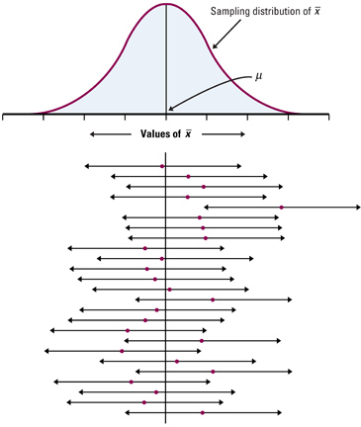
Key Concepts:

Confidence Interval Graphical Interpretation:
- Based on the sampling distribution of x-bar, the unknown population mean will lie in the interval determined by the sample mean, x-bar, 95% of the time (where 95% is a set value).
- In the example to the right, only 1 out of 25 confidence intervals formed by x-bar does the interval not include the unknown μ

Assumptions Using Z- Confidence Interval
- Sample: simple random sample (SRS)
- Sample Population: sample size must be large (n ≥ 30) or the population must be normally distributed. Dot plots, histograms, normality plots and box plots of sample data can be used as evidence if population is not given as normal
- Population σ: known (Not true on AP test usually!)
Confidence Interval Form:

Example 1: We are trying to estimate the true mean IQ of a certain university’s freshmen. From previous data we know that the standard deviation is 16. We take several random samples of 50 and get the following data:
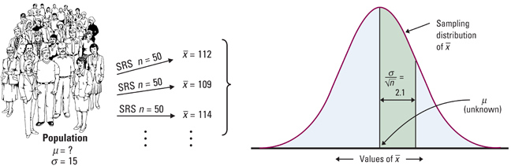
The sampling distribution of x-bar is shown to the right with one standard deviation (16/√50) marked.

Example 2: A HDTV manufacturer must control the tension on the mesh of wires behind the surface of the viewing screen. A careful study has shown that when the process is operating properly, the standard deviation of the tension readings is σ=43. Here are the tension readings from an SRS of 20 screens from a single day’s production. Construct and interpret a 90% confidence interval for the mean tension μ of all the screens produced on this day.
269.5 | 297.0 | 269.6 | 283.3 | 304.8 | 280.4 | 233.5 | 257.4 | 317.4 | 327.4
264.7 | 307.7 | 310.0 | 343.3 | 328.1 | 342.6 | 338.6 | 340.1 | 374.6 | 336.1
- Parameter:
- Conditions:
- Calculations:
- Conclusions:

Example 3: We tested a random sample of 40 new hybrid SUVs that GM is resting its future on. GM told us that the gas mileage was normally distributed with a standard deviation of 6 and we found that they averaged 27 mpg highway. What would a 95% confidence interval about average miles per gallon be?

- Parameter:
- Conditions:
- Calculations:
- Conclusions:

Example 4: GM told us the standard deviation for their new hybrid SUV was 6 and we wanted our margin of error in estimating its average mpg highway to be within 1 mpg. How big would our sample size need to be?

Homework:
Day 1: problems 10.1, 2, 6, 8, 9, 11
Day 2: problems 10.13, 14, 17, 18, 22, 23
Section 10.2: Estimating a Population Mean

Knowledge Objectives: Students will:
Identify the three conditions that must be present before estimating a population mean.
Explain what is meant by the standard error of a statistic in general and by the standard error of the sample mean in particular.
List three important facts about the t distributions. Include comparisons to the standard Normal curve.
Describe what is meant by paired t procedures.
Explain what is meant by a robust inference procedure and comment on the robustness of t procedures.
Discuss how sample size affects the usefulness of t procedures.

Construction Objectives: Students will be able to:
Use Table C to determine critical t value for a given level C confidence interval for a mean and a specified number of degrees of freedom.
Construct a one-sample t confidence interval for a population mean (remembering to use the four-step procedure).
Calculate a level C t confidence interval for a set of paired data.

Vocabulary:
Standard Error of the Mean – standard deviation from sampling distributions (σ/√n)
t-distribution – a symmetric distribution, similar to the normal, but with more area in the tails of the distribution
Degrees of Freedom – the sample size n minus the number of estimated values in the procedure (n – 1 for most cases)
Z distribution – standard normal curves
Paired t procedures – before and after observations on the same subject
Robust – a procedure is considered robust if small departures from (normality) requirements do not affect the validity of the procedure

Key Concepts:

Conditions for t-procedures: Same as before (SRS, Normality (or n large for CLT to apply), Independence)

Properties of t-distribution:
- The t-distribution is different for different degrees of freedom
- The t-distribution is centered at 0 and is symmetric about 0
- The area under the curve is 1. Area under the curve to the right of 0 equals area under the curve to the left of 0, is ½
- As t increases without bound (gets larger and larger), the graph approaches, but never reaches 0 (like an asymptote). As t decreases without bound (gets larger and larger in the negative direction) the graph approaches, but never reaches, 0
- The area in the tails of the t-distribution is a little greater than the area in the tails of the standard normal distribution, because we are using s as an estimate of σ, thereby introducing further variability.
- As the sample size n increases the density of the curve of t get closer to the standard normal density curve. This result occurs because as the sample size n increases, the values of s get closer to σ, by the Law of Large numbers.

Example of t-critical values:
n | Degrees of Freedom | t_{0.025} | Robustness and Outliers
6 | 5 | 2.571 | - Both t and z procedures for confidence intervals are robust for minor departures from Normality
16 | 15 | 2.131 | - Since both x-bar and s are affected by outliers, the t procedures are not robust against outliers
31 | 30 | 2.042
101 | 100 | 1.984 | In Reality
1001 | 1000 | 1.962 | - When σ is unknown we use t-procedures no matter the sample size (always hit on AP exam somewhere)
Normal | “Infinite” | 1.960

Example 1: We need to estimate the average weight of a particular type of very rare fish. We are only able to borrow 7 specimens of this fish and their average weight was 1.38 kg and they had a standard deviation of 0.29 kg. What is a 95% confidence interval for the true mean weight?

- Parameter:
- Conditions:
- Calculations:
- Conclusions:

Example 2: We need to estimate the average weight of stray cats coming in for treatment to order medicine. We only have 12 cats currently and their average weight was 9.3 lbs and they had a standard deviation of 1.1 lbs. What is a 95% confidence interval for the true mean weight?

- Parameter:
- Conditions:
- Calculations:
- Conclusions:

Example 3: 11 people addicted to caffeine went through a study measuring their depression levels using the Beck Depression Inventory. Higher scores show more symptoms of depression. During the study each person was given either a caffeine pill or a placebo. The order that they received them was randomized. Construct a 90% confidence interval for the mean change in depression score.
Subject | 1 | 2 | 3 | 4 | 5 | 6 | 7 | 8 | 9 | 10 | 11
P-BDI | 16 | 23 | 5 | 7 | 14 | 24 | 6 | 3 | 15 | 12 | 0
C-BDI | 5 | 5 | 4 | 3 | 8 | 5 | 0 | 0 | 2 | 11 | 1

- Parameter:
- Conditions:
- Calculations:
- Conclusions:

Example 4: Can t-procedures be used?
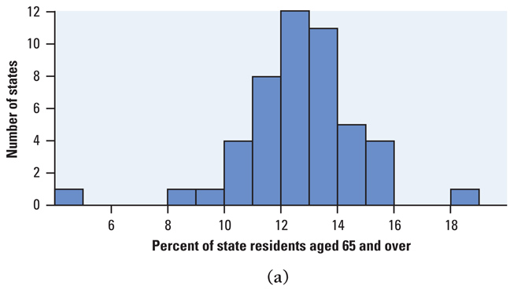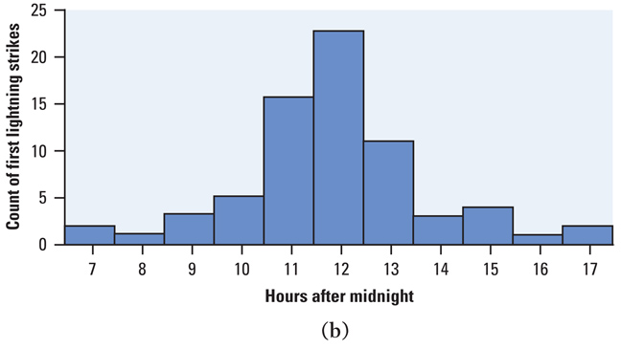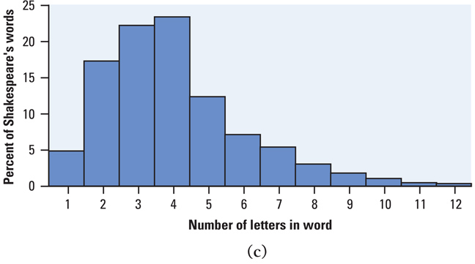

Homework:
Day 1: pg 648 – 650; 10.27-10.31
Day 2: pg 657 – 661; 10.34, 35, 37, 38, 41
Section 10.3: Estimating a Population Proportion

Knowledge Objectives: Students will:
List the three conditions that must be present before constructing a confidence interval for an unknown population proportion.

Construction Objectives: Students will be able to:
Given a sample proportion, , determine the standard error of .
Construct a confidence interval for a population proportion, remembering to use the four-step procedure (see the Inference Toolbox, page 631).
Determine the sample size necessary to construct a level C confidence interval for a population proportion with a specified margin of error.

Vocabulary:
Standard Error of p-hat – standard deviation of the sampling distribution of p-hat

Key Concepts:

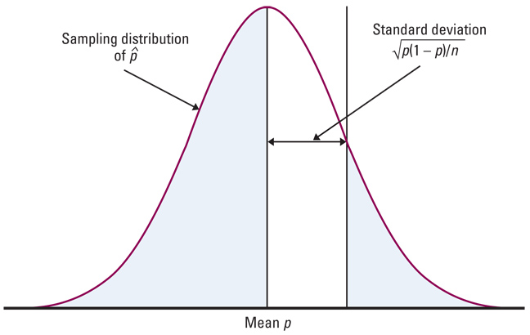
Conditions for p-hat intervals:
- SRS – the data are from an SRS from the population of interest
- Normality – for a confidence interval, n is large enough so that both
np and n(1-p) are at least 10 or more
- Independence – individual observations are independent and when sampling without replacement, N > 10n

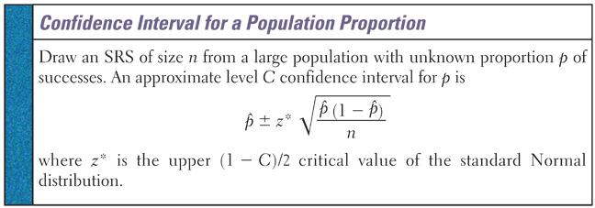

Example 1: The Harvard School of Public Health did a survey of 10.904 US college students and drinking habits. The researchers defined “frequent binge drinking” as having 5 or more drinks in a row three or more times in the past two weeks. According to this definition, 2486 students were classified as frequent binge drinkers. Based on these data, construct a 99% CI for the proportion p of all college students who admit to frequent binge drinking.

- Parameter:
- Conditions:
- Calculations:
- Conclusions:

Example 2: We polled n = 500 voters and when asked about a ballot question, 47% of them were in favor. Obtain a 99% confidence interval for the population proportion in favor of this ballot question (α = 0.005)

- Parameter:
- Conditions:
- Calculations:
- Conclusions:

Example 3: In our previous polling example, how many people need to be polled so that we are within 1 percentage point with 99% confidence?

Homework:
Day 1: problems 10.45, 46, 51, 52, 62, 63, 64
Chapter 10: Review

Objectives: Students will be able to:
Summarize the chapter
Define the vocabulary used
Describe statistical inference.
Describe the basic form of all confidence intervals.
Construct and interpret a confidence interval for a population mean (including paired data) and for a population proportion.
Describe a margin of error, and explain ways in which you can control the size of the margin of error.
Determine the sample size necessary to construct a confidence interval for a fixed margin of error.
Compare and contrast the t distribution and the Normal distribution.
List the conditions that must be present to construct a confidence interval for a population mean or a population proportion.
Explain what is meant by the standard error, and determine the standard error of and the standard error of .
Successfully answer any of the review exercises

Vocabulary: None new

Problem Format to follow:
- Parameter:
- Conditions:
- Calculations:
- Conclusions:

Confidence Interval Review:
- All confidence intervals (CI) looked at so far have been in form of
Point Estimate (PE) ± Margin of Error (MOE)
- PEs Unbiased estimators of population parameters
  - x-bar for μ
  - p-hat for p
- MOEs have been in form of CL×SE
  - CL = z or t critical value based on confidence C=area under curve
    - If σ is known we use it and Z_{1-α/2} for CL
    - If σ is not known we use s to estimate σ and t_{α/2} for CL
    - We use Z_{1-α/2} for CL when dealing with p-hat
  - SE = ‘σ_{x-bar or p-hat}’
    - Same as for sampling distributions

Confidence Interval Conditions:
- SRS (simple random sample)
- Normality
  - Population stated as normal
  - Sufficiently large sample size (>30) for CLT to apply
  - Small sample size
    - Check graphs (box plot or normality plot) to see if normality is a stretch
- Independence
  - Sample size less than 10% of the population

Sample Size Needed:
- If previous estimate of p-hat is known, then use it in: n = (p-hat)(1 – p-hat)×[z*/MOE]²
- If no previous estimate of p-hat is known, then use worst case: n = 0.25×[z*/MOE]²

Homework: pg 681-682 10.66, 68, 69, 71, 72, 73

